**IMAGE DATA ASSOCIATION.**

**TASK.**

Perform a mean shift clustering on a set of multiview images then later perform pixel-wise segmentation on a dataset.

**MEAN SHIFT ALGORITHM.**

Mean-Shift is another known unsupervised clustering algorithm. The algorithm assign the feature vectors to the clusters iteratively by shifting points towards the highest density of feature points in region.  
Mean-shift algorithm has so many fields. One of them are image processing and computer vision. In this assignment the mean shift clustering will be used for image segmentation.

**Running Single Image.**

Running a single image through the mean shift algorithm to try the model and see the result an also tune the hyper-parameter this will be useful when making the mask segmentation.

The only parameter to tune is the bandwidth which was done using the estimate bandwidth from the scikit learn library. This is the results below.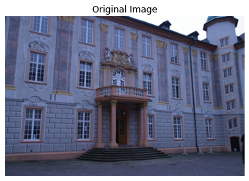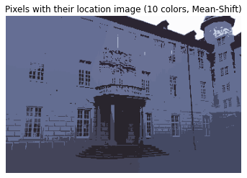

**Running Multiple Image.**

The goal of the task of running multiple images is to perform clustering using image descriptors as point to classification of different images.

An image descriptor is the description of an image by different attributes if the different image have the same points it will form the same cluster. For this task the HOG descriptor was used.

Example of the result of the HOG descriptor.

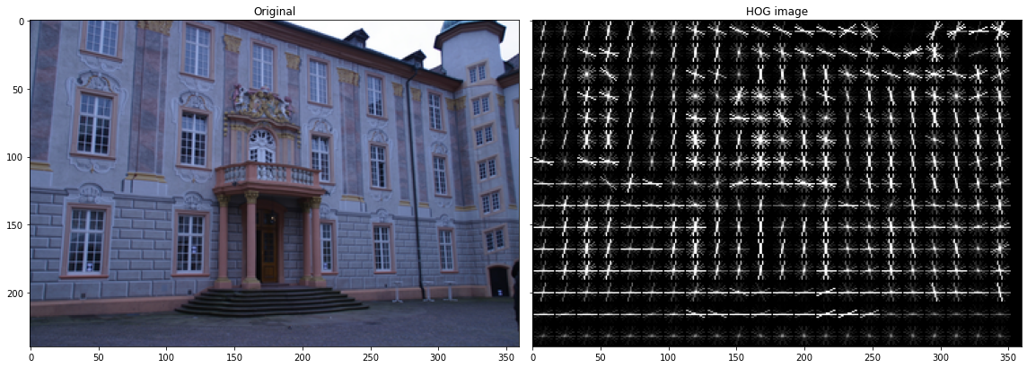

Then the next step was to do image classification using this method and the mean shift algorithm if the objects tend to the same mean they are of one cluster.

Three data sets each giving three images where run and the result was 6 clusters. This can be corrected by having a large corpus but due to the computation complexity of the mean shift algorithm it presented a challenge.

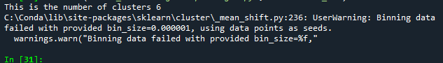

**SEGMENTATION.**

This will be done using the obtained from the mean shift model as a mask to mask out the foreground. This was like masking that is usually done in adobe or other graphics platform. Or in simpler terms selecting the odd one out.

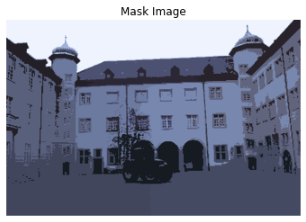

By performing the mean shift clustering similar point cluster and fore example the above image can be separated from background and foreground using values.

This is the segmentation attained after running a simple Otsu thresholding.

